Automatic Hand Dispenser and Temperature Scanner for Covid – 19 Prevention (ACM:IA-I-RRL-PM-R-A)

Joel Fortuna Tadle (student)

Bachelor of Science in Computer Engineering, College of Engineering, Architecture and Industrial Design, Bohol Island State University-Main Campus, [joel.tadle@bisu.edu.ph](mailto:joel.tadle@bisu.edu.ph)

 MAX ANGELO DAPITILLA PERIN (INSTRUCTOR)

Faculty of Department of Computer Engineering, College of Engineering, Architecture and Industrial Design, Bohol Island State University-Main Campus, [maxangelo.perin@bisu.edu.ph](mailto:maxangelo.perin@bisu.edu.ph)

**Imaginative abstract:** This design is to provides the preventive measure taken, during the COVID-19 pandemic. Sanitizers have become the most important commodities in the entire world. By the new rules and regulations delivered by “World Health Organization” states that sanitization is needed to encounter the new normal. This system uses Arduino Uno, ultrasonic-sensor, contactless, automatic, temperature sensor, LED, DC motor, pump, relay switches. In a contactless sanitising machine, the design incorporates anautomatic hand sanitizer with a temperature detecting system to keep hands sanitised anytime a person desires. The temperature sensor senses gives the body temperature of the person. The system is deliberate to help prevent the spread of covid-19 infection and in improving community health. The system ensures precise progression of sanitizer essentially fluid up to 5 sec. Additionally, the system design is simple to establish, easy to use and, exact motion of the hand is identified. Considering, the worldwide situation, sanitization should be installed in industries, corporate office, educational institution and educational institution. This automatic hand sanitizer with temperature sensing scanner will definitely be a promising tool to ensure contactless application.

**CCS CONCEPTS** • Hardware • Emerging Technologies • Electromechanical Systems • Microelectromechanical Systems

**Additional** **Keywords and Phrases:** Arduino Uno, ultrasonic-sensor, contactless, automatic, temperature sensor.

**ACM Reference Format:**

**Joel Fortuna Tadle**, **MAX ANGELO DAPITILLA PERIN**. 2022**. Automatic Hand Dispenser and Temperature Scanner for Covid – 19 Prevention (ACM:IA-I-RRL-PM-R-A).** In Research Project Presentation for Bachelor of Science in Computer Engineering 3 in CPE 323 – Microprocessor Systems S.Y. 2021-2022, 2nd Semester, Bohol Island State University-Main Campus, Tagbilaran City, Republic of the Philippines. ACM, New York, NY, USA

1. **Introduction**

This project is to provide the design and implementation of a contactless temperature scanner and sanitizer dispenser system is presented. The system is implementation to prevent the spread of covid-19 virus and assist in improving society health and reduce the rate of risk. Affecting the most prestigious countries in a chain like China , Italy ,Spain , USA , India , Russia, the virus has proved it’s strength and subservient a technologically enhanced race. Alcohol based hand-sanitizers can inactivate the virus[1]. A global pandemic was triggered by the spread of the life-threatening Severe Acute Respiratory Syndrome Corona Virus (SARS-COVID-19). Alcohol base hand sanitizer is mandatory to protect ourself from covid- 19[3]. As there is an impact in the existing foot pressed sanitization system which can spread of the virus from one person to another[2]. The system is also made to be readily available and at a cheaper cost so that everyone can be afford.To truly attract finishing up line to extend, it can in every practical sense be really said that exceptionally Human actually have a creative psyche that can without much of a stretch basically eliminate the dread And can Change any circumstance effectively, exhibiting how this gadget truly is produced using reusing kind of material and doesn't, influence on Environment, genuinely as opposed to main stream thinking.

1. **REVIEW OF RELATED LITERATURE**

In[1], the paper says about the spread of corona virus and its causes. They employ a proximity sensor to detect the presenceof adjacent objects, but the primary disadvantage is that it might be accidentally activated, causing problems, and it only recognizes metallic targets. They are primarily concerned with hospital-acquired infections, which impact around 2 million people each year and are the eighth leading cause of death in the United States. In[2], they mainly use hand sanitizers with 60% to 70% of ethanol for decreasing the total number of significant pathogens. Using hand-sanitizers over 10-months can reduce the overall spread by 36%. Here the author explains the importance of hand washing but washing our hands with regular soap and water is time consuming in hospitals. In[3], A Novel Automatic Sanitizer Dispenser [2020] The microcontroller used in this paper is Arduino nano which is smaller when compared to Arduino uno. This the main drawback of the system and also there is no external power supply source. The entire time taken for the whole procedure is approximately 4 seconds. In[4], They'll be employing an Arduino Uno and an ultrasonic sensor, but they'll be able to increase the system's overall performance while lowering its cost. The author compared the differences between normal soaps and alcohol-based hand sanitizers. When there is presence of the hand within therequired range, the sound waves from the sensor are sent to the micro-controller which in turn triggers a relay board to activate the motor which causes the pumping of the sanitizer. In[5], The authors conducted study to see if traditional hand pump sanitizer dispensers could be contaminated. They did this by growing bacteria in various areas of sanitizer dispensers and watching how it grew when people used them. They discovered that all hand sanitizer dispensers have a high level of collocation on the lever, which is in direct contact with the user's hand. They came to the conclusion that hand sanitizer dispensers can become contaminated with diseases and hence pose a threat to humans. It is clear how important itis to use touchless automatic sanitizer dispensers.

1. **PROPOSED METHODOLOGY**

The system's main goal is to provide a contactless sanitising machine as well as a temperature scanner. This system differs from other systems in that it includes a temperature sensor.

1. **Hardware Overview**

**Arduino UNO** is a microcontroller board based on the **ATmega328P**. It has 14 digital input/output pins (of which 6 can be used as PWM outputs), 6 analog inputs, a 16 MHz ceramic resonator, a USB connection, a power jack, an ICSP header and a reset button. It contains everything needed to support the microcontroller; simply connect it to a computer with a USB cable or power it with a AC-to-DC adapter or battery to get started. You can tinker with your UNO without worrying too much about doing something wrong, worst case scenario you can replace the chip for a few dollars and start over again.

**Ultrasonic sensors** are used primarily as [proximity sensors](https://www.fierceelectronics.com/sensors/what-a-proximity-sensor). They can be found in automobile self-parking technology and anti-collision safety systems. Ultrasonic sensors are also used in robotic obstacle detection systems, as well as manufacturing technology. [In comparison to infrared (IR) sensors](https://www.maxbotix.com/articles/ultrasonic-or-infrared-sensors.htm) in proximity sensing applications, ultrasonic sensors are not as susceptible to interference of smoke, gas, and other airborne particles (though the physical components are still affected by variables such as heat).

A **temperature sensor** is an electronic device that measures the temperature of its environment and converts the input data into electronic data to record, monitor, or signal temperature changes. There are many different types of temperature sensors. Some temperature sensors require [direct contact](https://www.electronics-tutorials.ws/io/io_3.html) with the physical object that is being monitored (contact temperature sensors), while others indirectly measure the temperature of an object (non-contact temperature sensors).

Table 1. List of Components used in the study.

|  |  |
| --- | --- |
| Arduino Uno | Temperature sensor LM35 |
| LED | TSOP |
| Buzzer | Pump |
| Relay Switches |  |
| Ultrasonic sensor |  |

1. **Components Used**

* The table 1. Consist the various components that will making in this project. The one main components that will in this project would be the Arduino Uno Microcontroller, Temperature sensor LM35, Ultrasonic sensor, and the LCD. This components are the main used of this project.

1. **Circuit Diagram of Temperature sensor using Arduino UNO**

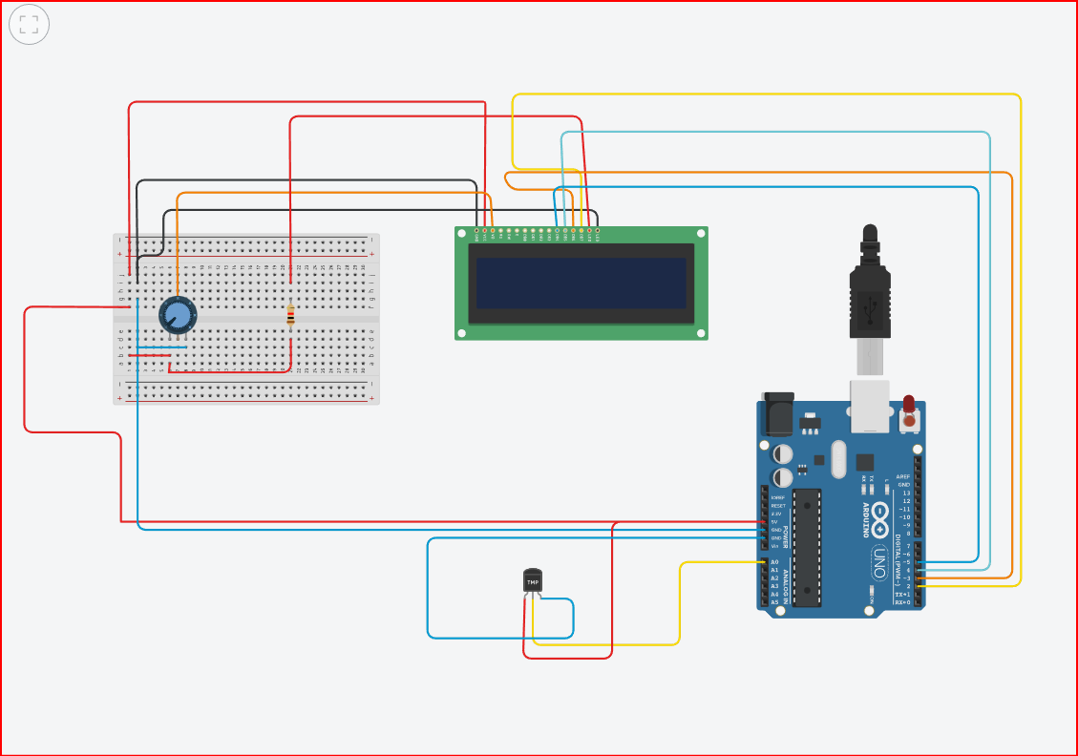

1. **IMPORTANT CODE**

#include <LiquidCrystal.h>  
float temp;  
int sensor = A0;  
float tempc;  
float tempf;

LiquidCrystal lcd (12, 11, 5, 4, 3, 2);

The instance of the LiquidCrystal lcd shows LCD pins connected to the Arduino digital outputs.

void setup () {  
// set the number of columns and the number of lines of lcd  
lcd.begin (16, 2);  
}

void loop () {  
temp=analogRead(sensor);

Read analog voltage from sensor and store it in a temporary float variable.

tempc=(temp*4.88)/10;

This line converts float value into °C.

tempf=(tempc*1.8)+32;

This line converts °C into Fahrenheit.

lcd.setCursor(0,0);  
lcd.print(“Temp in C = “);  
lcd.println(tempc);

These two lines print Temperature value in °C.  
lcd.setCursor(0,1);  
lcd.print(“Temp in F = “);  
lcd.println(tempf);

Above two lines print value in Fahrenheit  
}

**REFERENCES**

**Jessica Hillburn MT(ASCP), CIC, Brian S Hammond, Elanor J Fendler PhD, Patricia A**

**Groziak MS, "Use of alcohol hand sanitizer as an infection control strategy in acute care**

**facility", American Journal of infection control Volume 31, Issue 2, April 2003.**

**4366 | Dr. B Sumathy Automatic Hand Dispenser & Temperature Scanner For**

**Covid-19 Prevention**

**[2] Satoru Mitsuboshi, Masami Tsugita, "Impact of alcohol- based hand sanitizers, antibiotic**

**consumption, and other measures on detection rates of antibiotic resistant bacteria in rural**

**Japanes hospitals", Journal of Infection and Chemotherapy, 2018.**

**[3] M. M. Srihari, “Self-Activating Sanitizer With Battery Imposed System For Cleansing**

**Hands,” 2020 Second International Conference on Inventive Research in Computing**

**Applications (ICIRCA), Coimbatore, India, 2020, pp. 1102- 1105.**

**[4] Akshay Sharma A S, “Review on Automatic Sanitizer Dispensing Machine,” International**

**Journal of EngineeringResearch & Techniology (IJERT) Volume 09, 07 July 2020.**

**[5] https://www.instructables.com/id/DIY-Easy-Non Contact Automatic-Hand-SanitizerDisp/**

**[6] Suryawanshi VR, Surani HC, Yadav HR. Formulation, evaluation and anti-microbial**

**eciency of alcohol based herbal hand sanitizer. Int J Eng Sci Comput 2020;12: 25113-15**

**[7] Wu F, Zhao S, Yu B, Chen YM, Wang W, Song ZG, et al.A new coronavirus associated with**

**human respiratory disease in China. Nature. 2020;579(7798):265–9.**

**[PMC free article] [PubMed] [Google Scholar]**

**[8] Davis MA, Sheng H, Newman J, Hancock DD, Hovde CJ.Comparison of a waterless handhygiene preparation and soap- and-water hand washing to reduce coliforms on hands in**

**animal exhibit settings. Epidemiol Infect. 2006;134:1024– 1028**

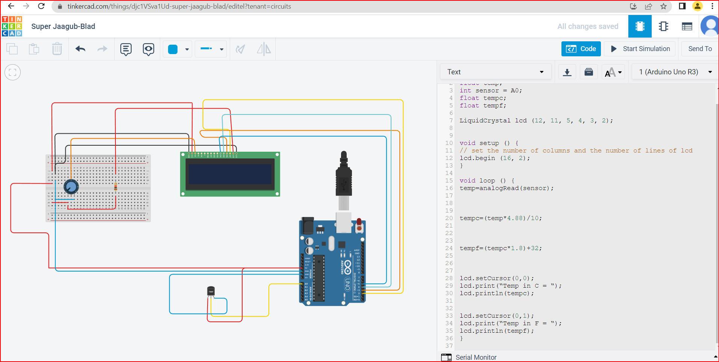**APPENDICES**